HUNTINGDON BOAT CLUB HEAD OF THE RIVER RACE

SAFTY PLAN 28/10/18

- Introduction:
- Event Organisation:
  - Event Organising Committee
  - Communication
    - Following parties are informed of the event prior to the day
    - Communication with competitors prior to the event
    - Communication during the event
  - Prior to the event
  - On the day of the event
  - Marshals
  - Parking
  - Landing stage
  - First Aid
- Safe procedures and preventive measures
  - Equipment
  - Swimming ability
  - Marshalls
- Accident and Emergency Procedures
  - Contact details in the event of an emergency:
  - Off the water
  - On the water
4.4 Extreme weather conditions
- Welfare Plan
- Appendix
6. A Risk assessment
6. B Course Map
6. C Marshalling instructions for compositing crews
6. D Safety instructions for competition crews
6. E Parking
6. F Schedule of the day

1. Introduction:

Huntingdon Boat Club Head of the River is a rowing competition run on the River Great Ouse. The event is held under British Rowing Rules of Racing.

This Safety Plan incorporates the key points of the British Rowing publication 'Row Safe and a ‘Guide to Good Practice in Rowing', and should be read by every cox and crew member. This plan is a local extension, for the duration of the Huntingdon Head of the River, of British Rowing’s Guide to Safe Practice in Rowing.

A copy of the Safety Plan is lodged with British Rowing Regional Water Safety Officer and St John’s Ambulance who will be present during the whole event.

A risk assessment has been completed (Appendix A) covering all activities on the day including rowing and land based undertaking. Many of the points raised in this Safety Plan are to ensure that the assessed risks are mitigated to an acceptable level.
2. Event Organisation:

2.1 Event Organising Committee:

 | Name | Contact No | Email
Head of the River Secretary | Jonathan Deacon | 07941995102 | jonathan-deacon@hotmail.co.uk
Club Water Safety Adviser: | Paul Adair | 07789728820 | pauladair19@googlemail.com
Rescue launch co-ordinator | Daniel Heathcote | 07947692982 | dnlheathcote@yahoo.co.uk
Event Welfare Officer: | Alice Ray | 07925145388 | aliceb8@sky.com
Race Committee
Chairman of Race Committee: | Graham Adams | 07711081286 | adamsgraham@btconnect.com
Umpire | Chris Parkhouse | N/A | N/A
Umpire | Andrew Blit | N/A | N/A

2.2 Communication:

2.2.1 Following parties are informed of the event prior to the day:

Name | How | Who
Environment Agency | Telephone | Organising Committee
Hartford Marina | Letter | Organising Committee
Purvis Marina | Letter | Organising Committee

2.2.2 Communication with competitors prior to event:

All competitors will be sent instructions on the event via email and if email is not available post. If in the event of cancelation this will be done by the Organising Committee via email and telephone.

2.2.3 Communication during the event:

All marshals, event organisers, the Race Committee and St Johns Ambulance will communicate with each other via VHF radios plus mobile phones for backup.

Communication between marshals and competitors on the water will be done via loud haler.

2.3 Prior to the event

The event will be organised by the Organising Committee over a series of meeting, briefing and email.

2.4 On the day of the event

The event will be co-ordinated by the Regatta Secretary and a member of Huntingdon Boat Club will be allocated to co-ordinate following areas to ensure safety procedures and preventive measures are followed and in the event of an incident or emergency the correct procedures are followed:

Race Control, Parking, Landing stage, Marshalls, Landing stage

2.5 Marshalls

The following Marshals and safety equipment will be present on the course:
Location | Safety equipment
Holding area for crews waiting to go to the start line | Loud haler, VHF radio, mobile
Start | Loud haler, VHF radio, mobile
Rescue launch 4x (two on each boat) | Loud haler, VHF radio, mobile, thermal blankets.
Finish | Loud haler, VHF radio, mobile
Hold area after finish | Loud haler, VHF radio, mobile

2.6 Parking

Parking for competitors / supports cars for the event will be on the car park next to Huntingdon Boat Club and trailers and towing vehicles will be parked on the playing field next to Huntingdon Boat Club (See appendix 6.E). A marshal will be present to direct cars / trailer safely on their arrival.

2.7 Landing stage

Boats will enter and leave the water at the start and finish of each division via the land stage. A marshal will be present to direct boats and an umpire will be check equipment through out the day.

2.8 First Aid

First aid will be supplied by St John Ambulance. They will be located outside the boat house.

3. Safe procedures and preventive measures

3.1 Equipment

It is the responsibility of each crew to ensure that the equipment that they are using is safe and compliant with the requirements of British Rowing’s Rules of Racing and Guide to Safe Practice in Rowing.
Coxes arriving at the start without lifejackets will be disqualified. Coxes of front-loading boats should ensure that their life jackets allow for a quick escape from their boat.
All boats must have secure bow balls, heel restraints and watertight buoyancy chambers. Spot checks on equipment will take place during the day.
All competitors are to wear suitable appropriate clothing that is warm and waterproof enough to last the duration of being on the water (crews can be on the water for up to 1 ½ hours). To help identify crews it is asked that during the race clubs wear your correct club racing kit as stated in the British Rowing Almanack. Competitors are to ensure they carry enough drink and provisions with them to last the duration of being on the water.

3.2 Swimming Ability:

Every competitor is expected to be in good health and able to swim for a minimum of 100 metres in kit. Although the river is fairly narrow and access from the bank relatively good, there are areas of dangerous undercurrent.

3.3 Marshals

Rescue launches will be crewed by trained / experienced personnel will be monitoring the course throughout the event and will be co-ordinated by Daniel Heathcote who has RYA Powerboat level 2 and is a trained Water Rescue Instructor.

Rescue launches will have VHF radio and mobile for back up to maintain contact with other marshals, Race Control and Umpires
Radio etiquette shall be maintained at all times and only relevant event information shall be relayed by radio. Messages may also have to be relayed due to limited range down the course.

4. Accident and Emergency Procedures:

4.1 Contact details in the event of an emergency

 | Contact details
First Aid cover
St John Ambulance | Located outside boat house and also can be contacted via VHF radio.
Emergency Services
Hinchingbrooke Hospital (nearest hospital with A&E). Approximate travel time is 10 minutes | Hinchingbrooke Park, Huntingdon, Cambridgeshire, PE29 6NT  Tel: 01480 416416 or 999  See below map (A) Huntingdon Boat Club (B) Hinchinbrook Hospital  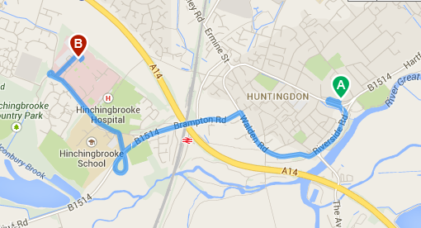
Huntingdon Police station | Ferrars Rd,Huntingdon,Cambridgeshire,PE29 3DQ  Tel# 01480 415541 or 999
Fire Service | 999
Other key contacts
Regatta Secretary – Jonathan Deacon | Tel# 07941 995102
Safety Officer – Paul Adair | Tel# 07789 728820
Welfare Office – Alice Ray | Tel# 07925 145388
Chairman of the Race Committee | Tel# 07711 081286
Environment agency | Tel# 0370 8506506
Huntingdon Boat Club | Tel# 01480 456963

4.2 Off the water

In the event of an Emergency off the water this needs to be reported to any marshal, Umpire or member of the Organizing Committee and in the event of first aid, St Johns Ambulance.

4.3 On the water

In the event of an emergency during the event be it medical / competitors in the water etc. then the following protocol will be adopted.
When an emergency arises this will be in the 1st place dealt with by a safety boat / umpire. This will be in the form of alerting all by means or radio that there is an emergency. On receiving this the safety co-ordinator (Dan Heathcote) will be the lead in co-ordinating the response.
Radio messages are to go through the safety co-ordinator who will send the required resources to the location.
The co-ordinator will also liaise with the umpires at the start and finish should the event be affected.
In the event emergency services are required then these will be called and directed to the correct RVP by the safety co-ordinator on advice from the personnel on scene.

The RVP for reference are:
Houghton Mill (PE28 2AZ) – Start.
Daylock marina (PE28 2FN) – Approx. 500m into course.
Hartford Marina (PE28 2AA) – Half way.
Hartford Church (PE29 1XP) - 2500m into course.
Huntingdon Boat Club (PE29 3RP) – Finish.

In the event of a possible cardiac arrest the safety launch is to take the person to Huntingdon Boat Club immediately where St John’s ambulance will be on hand with an AED.

A risk assessment of the course will be conducted before the event to ensure river conditions, weather conditions and hazards on the course are within the safety parameters.

Type of incident
Capsize | In the event of a capsize, the crew are to stay with their boat and wait for a marshal to assist in their rescue.
Collision on the course | Any damaged boat which is unable to proceed should be moved to the bank side without delay and wait for a marshal for assistance.
Extreme weather | See 4.4
River blockage / floating hazards | If the course is blocked a marshal shall advise the start and finish and hold the division until course is clear. Any significant floating debris or “hazard” seen on the water shall be reported to Race Control immediately. A Rescue Launch shall be deployed to clear the water and racing shall be suspended.
Person falls ill and unable to carry on with the event. | If any person falls ill and is unable to carry on with the course a marshal needs to be made aware and they will then contract the relevant contact (s) listed in 4.1

4.4 Weather / river conditions

The Race Committee, together with the Safety Adviser, will monitor weather conditions on the days prior to and during the competition. In the event of adverse weather conditions competitors may be limited to those with more experience, events may be withdrawn or the competition may be suspended or cancelled. The Race Committee along with the organisers may halt racing if safety or fairness are compromised.

Conditions that will be taken into consideration:

River current | river level | visibility | thunder and lightning | ice

Should thunder and lightning occur the British Rowing 30/30 guidance for clearing the water and seeking shelter will be applied. The Race Committee along with the organisers will monitor the forecasts and current weather conditions for thunder and lightning and either cancel the event or notify the competitors of the possibility of a thunderstorm. If thunder is heard within 30 seconds of a flash of lightning the organisers will assess the risk with a view to stopping the event. Restarting the event will be after thirty minutes from the last clap of thunder. The umpires will give clear guidance for the procedures to be adopted if a thunderstorm is on the vicinity.

5. Welfare plan:

The organisers of Huntingdon Boat Club believe that the welfare and wellbeing of all competitors is paramount. All junior competitors have a right to safety and protection. All children, regardless of age, gender, ethnicity, religion or ability, have equal rights to safety and protection. All suspicions, concerns and allegations of harm will be taken seriously and responded to swiftly and appropriately.
It is expected that the welfare of junior competitors is primarily the responsibility of the competing clubs own coaches and officers, or individual parents accompanying their children.
In the event of a junior being involved in any incident, the responsible adult will be identified from the competitor’s entry form. The named person will be contacted by the mobile phone number given on the entry form.
It is the responsibility of the coach or parent accompanying juniors to monitor their whereabouts. In the event of any junior crew member going missing the responsible adult must take appropriate action. In the first instance the relevant person from 4.1 needs to be contacted. The named adult, or in their absence, the contact from 4.1, is responsible for deciding whether the local police should be contacted in the case of any incident. A contact number for each club is kept with the Head Secretary, Welfare office, and St John Ambulance.

6. Appendix

6. A Risk assessment:

HUNTINGDON BOAT CLUB HEAD OF THE RIVER RACE RISK ASSESSMENT

Identified Hazards |  | Risks Involved | Control Measures
COLLISION |  | • Speared by sharp bows | • Rubber ball on bows
 |  | ▪ | • Sample check of boats launching for safe boats
 |  | ▪ | • In unlikely event of swimmers in area -made aware by marshals.
 |  | ▪ | • Quick response by marshals
COLLISION |  | • Drowning | • Coxes wear life jackets
 |  | ▪ | • Crews instructed to stay with boat
COLLISION |  | • Immersion | • Thermal blankets/ showers/hot drinks available
COLLISION |  | Miscellaneous | • Coxes made aware of navigation rules
 |  | • Struck by blades | • Rescue launch available
 |  | • Skeletal injuries | • St Johns ambulance first aiders available
 |  | • Knocked unconscious | • Other river users warned of event by launches
 |  |  | • Map of course and guidance notes issued to all clubs & course marshals
WITH CONTROL MEASURES IN PLACE COLLISION IS ASSESSED TO BE A MEDIUM TO LOW RISK
Identified Hazards | Risks Involved |  | Control Measures
CATCHING A CRAB | • Winding |  | • St Johns ambulance first aiders available
 | • Thrown from boat |  | • Rescue launches and divers
 | • Drowning |  | • Cancellation of event in bad weather
 | • Head/facial injury
 | • Weather factor /river conditions enhancing risks
WITH CONTROL MEASURES IN PLACE CATCHING CRABS IS ASSESSED AS LOW RISK
Identified Hazards | Risks Involved |  | Control Measures
OVER EXERTION | • Pulled muscles |  | • Row to start allows crews to warm-up
 | • Cramp |  | • St Johns ambulance first aiders available
 | • Hyperventilation |  | • Rescue launch and drivers
 | • Cardiac arrest
 | • Blisters
WITH CONTROL MEASURES IN PLACE OVER EXERTION IS ASSESSED AS LOW RISK
Identified Hazards | Risks Involved |  | Control Measures
CAPSIZE | • Feet caught in boat |  | • Sample check of heel restraints at time of launching
CAPSIZE | • Immersion |  | • Foil blankets, showers and hot drinks available
 | • Hypothermia |  | ▪ Foil blankets, showers and hot drinks available
CAPSIZE | • Drowning |  | • Rescue launch and drivers
 | • Infection |  | • St Johns ambulance first aiders available
WITH CONTROL MEASURES IN PLACE CAPSIZE IS ASSESSED AS A MEDIUM TO LOW RISK
Identified Hazards | Risks Involved |  | Control Measures
TRANSPORT/TOWING | • Visiting clubs damage to boats/people. |  | • Clear directions and signage
 | ▪ |  | • Area allocated with cones to allow ample manoeuvrability. (in agreement with council)
 | ▪ |  | • Parking stewards
WITH CONTROL MEASURES IN PLACE TRANSPORT IS ASSESSED AS LOW RISK
Identified Hazards | Risks Involved |  | Control Measures
Barbeque/ catering | • Burning/ scolding |  | • St Johns ambulance first aiders available
 | ▪ |  | • Readily available cold water supply and first aid kits
Barbeque/ catering | • Food poisoning |  | • Cooking of relatively low risk foods, under direction of suitably trained individual(s)
WITH CONTROL MEASURES IN PLACE BBQ IS ASSESSED AS A LOW RISK
Identified Hazards | Risks Involved |  | Control Measures
Marquees | • Blowing away/ resulting injury |  | • Ensure those installing are competent and check installation.
Marquees | • Guy rope/peg trip hazard |  | • Mark with cones other means

Appendix 6.B:

Key: Safety boat | Marshall | Start (main head) | Start (mini head) | Finish

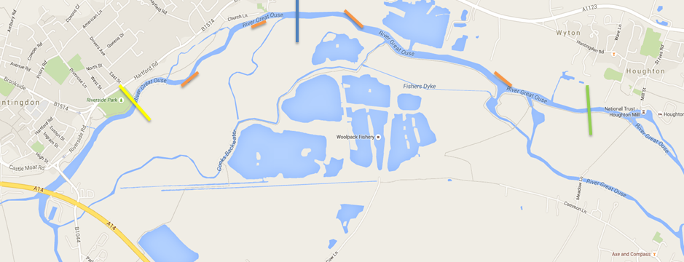
Appendix 6.C:

HUNTINGDON BOAT CLUB HEAD OF THE RIVER RACE

MARSHALLING & GENERAL INSTRUCTIONS FOR COMPETING CREWS

Thank for your entry to Huntingdon head of the river race. Please read the following points. All visiting clubs must brief their crews on these points before race day.

PARKING AND TRAILERS
Parking for competitors vehicles is available at the Pay & Display car park adjacent to the club. All trailers are to be parked on the playing field next to the boat club building.. No trailers or towing vehicles are permitted to drive onto the football pitch itself. Please be aware that this is a public car park and it will be in use by members of the public throughout the day. Do not block any entrances or exits as this may impede the emergency services. All valuables and money should be securely locked away and out of sight. Huntingdon Boat club cannot be held responsible for any loses.

BOATING
Please make sure you are on the water at least 45 minutes before the division start time and be past the start line at least 15 minutes before the division starts. Allow at least 30 minutes to get to the start. There will be marshals on the landing stage area and at the start to direct and help crews. You must obey any instruction given by the marshals.

START
At the start you will be marshalled into numerical order by the start marshals on the riverbank. You must obey all instructions given by the marshals. Please make sure your number is clearly visible and securely fastened at all times whilst on the water.

OVERTAKING AND STEERING
Faster crews have priority of the river over slower crews. Failure to allow faster crews to overtake could result in disqualification or a time penalty of the offending crew. The final decision is at the discretion of the race umpires. Please also be aware that where possible other river traffic will be stopped during racing however the river is not closed to navigation so crews must remain vigilant at all times especially where the river becomes narrower and the bends become sharp in the last 2000 metres and overtaking can become difficult. Therefore we ask only experienced coxswains & steersman are used at this event.

FINISH
At the finish, crews will be marshalled to the landing stage where they will exit the river.

DE-BOATING
The landing stage area can get congested at time. There will be marshals on the landing stage area to direct and help crews. You must obey and instructions given by the marshals. Crews are to form an orderly queue and wait their turn to get de-boated, by doing this you will avoid any unnecessary time wasting and get off the water faster. Any crews found to be pushing in or jumping the queue could face an official warning.

Your observation of these instructions is greatly appreciated by the organising committee.
Appendix 6.D:

HUNTINGDON BOAT CLUB HEAD OF THE RIVER RACE
SAFETY INSTRUCTIONS FOR COMPETING CREWS

Thank you for your entry to Huntingdon Head of the River Race. Please read the following points. All visiting clubs must brief their crews on these points before race day.

IN AN EMERGENCY
If you see an accident or capsize you must report it immediately to the nearest marshal (all marshals will be equipped with radios and water safety equipment). The safety boats and marshals will the take charge of the situation. Crews can give assistance but only if it is absolutely necessary and safe to do so, do not put yourself or crew in any unnecessary danger. You will be allowed to race again without penalty if you assist any crew in distress.

IN THE EVENT OF A CAPSIZE
During the event there will be marshals on the riverbank and on the safety boats. The bank and boat marshals will both be equipped with radios and the relevant water safety equipment. In the event of a capsize generally stay with your boat until help arrives (either from the safety boats of bank marshals). The safety boats and bank marshals will be in attendance during the duration of the racing divisions.

ACCIDENT ON LAND
St Johns Ambulance service will be on duty throughout the day to give assistance if any accidents occur. They will be situated in the boat/clubhouse area. Any accidents are to be reported to an official from Huntingdon Boat Club. The club can be contacted on (01480) 456963.

EQUIPMENT
All boats and equipment must meet the current BR safety standard as specified in the British Rowing Almanack. Official BR umpires will be on duty throughout the day to check the boats and equipment. Any boats or equipment failing to meet the required standard will not be allowed to race.

COMPETITORS/VISITING CLUBS RESPONSIBILITIES
All competitors including coxswains must be able to swim a minimum of 100 metres in race kit. All coxswains are to be the correct weight for racing and wear a fully approved life jacket at all times whilst on the water. Coxswains using front-loading boats must be capable of exiting the craft safely in the event of a capsize/accident. All competitors are to wear suitable appropriate clothing that is warm and waterproof enough to last the duration of being on the water (crews can be on the water for up to 1 ½ hours). To help identify crews it is asked that during the race clubs wear your correct club racing kit as stated in the British Rowing Almanack. Competitors are to ensure they carry enough drink and provisions with them to last the duration of being on the water.

Your observation of these instructions is greatly appreciated by the organising committee

Appendix 6.E
Key: car & trailer parking | boats | access to parking | football pitch (no parking)

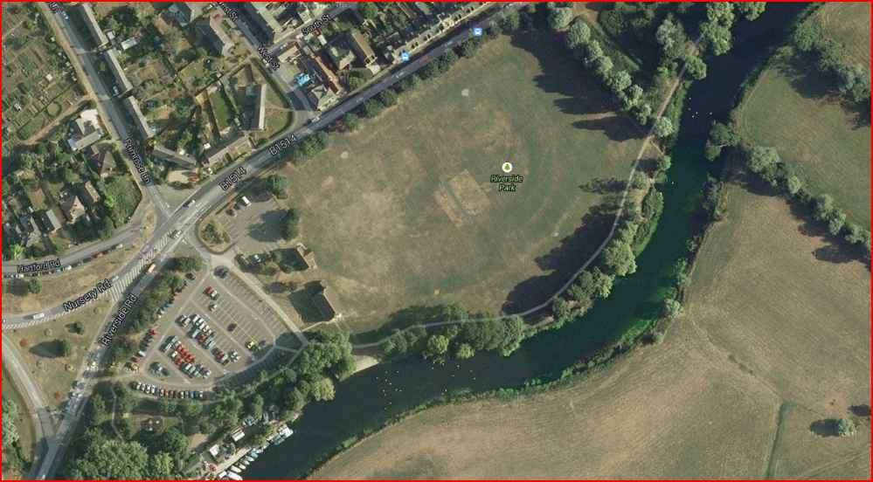

HUNTINGDON BOAT CLUB HEAD OF THE RIVER RACE
SCHEDULE & TIMINGS

GENERAL TIMINGS

- 08:00: Race control opens (located in the gym) for registration.
- 16:00: Full results issued and presentation of prizes to winning crews.

DIVISION TIMINGS

DIVISION 1

- 08:55: Safety launches ready to set off prior to crew setting off for start.
- 08:45: Crews begin to get boated and set off to start.
- 09:35: Safety launches, start marshals and all other marshals get into position.
- 09:40: Check course is clear of any river traffic before race starts.
- 09:45: Race starts.
- 10:30: Race finish (as last crew passes finish and is off the water).
- 10:45: Division 1 results issued.

DIVISION 2 – mini head

- 10:30: Safety launches start to move to mini head positions
- 10:45: Crews begin to get boated and set off to start of mini head.
- 11:00: Safety launches, start marshals and all other marshals get into position.
- 11:10: Check course is clear of any river traffic before race starts.
- 11:15: Race starts.
- 11:45 Race finish (as last crew passes finish and is off the water).
- 12:00: Division 2 results issued

DIVISION 3

- 11:45: Safety launches ready to set off prior to crews setting off for start.
- 10:45: Crews begin to get boat but stay between club and town bridge.
- 11:50: Crews make their way to start after mini head has finished.
- 12:15: Safety launches, start marshals and all other marshals get into position.
- 12:25: Check course is clear of any river traffic before race starts.
- 12:30: Race starts.
- 13:15: Race finish (as last crew passes finish and is off the water).
- 13:30: Division 3 results issued

DIVISON 4

- 13:20: Safety launches start to move to main head position.
- 13:30: Crews begin to get boated and set off to start.
- 14:15: Safety launches, start marshals and all other marshals get into position.
- 14:25: Check course is clear of any river traffic before race starts.
- 14:30: Race starts
- 15:15: Race finish (as last crew passes finish and is off the water).
- 15:30: Division 3 results issued

16:00: Prize giving

