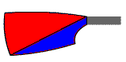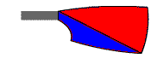

Key: Safety boat | Marshall | Start (main head) | Start (mini head) | Finish

